Instagram user Analytics project

1. Project description:

This project aims to analyze raw data Instagram data to derive valuable insights that can help businesses grow. By examining key metrics, the project provides actionable recommendations for optimizing marketing strategies and improving overall business performance on Instagram.

1. Approach:

The project was carried out using SQL and SQL queries were used to create the database in MYSQL workbench, followed by data cleaning to ensure accuracy. Sorting and extraction queries were implemented to obtain necessary insights.

1. Tech Stack Used:

MYSQL Workbench version v8.0.38.0 was used, which is an outstanding tool for querying the database due to its user-friendly and straightforward setup and interface.

1. Insights:
2. **Marketing** **Analysis**:
3. **Loyal User Reward: The marketing team wants to reward the most loyal users, i.e., those who have been using the platform for the longest time.  
   Your Task: Identify the five oldest users on Instagram from the provided database.**

**CODE:**

**select * from users**

**order by created_at asc**

**limit 5;**

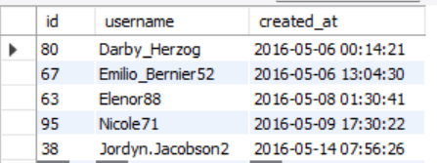

**CONCLUSION:** Theabove-mentioned are the top 5 oldest users on Instagram.

2) **Inactive User Engagement: The team wants to encourage inactive users to start posting by sending them promotional emails.  
Your Task: Identify users who have never posted a single photo on Instagram.**

**CODE:**

**select * from users**

**left join photos**

**on users.id= photos.user_id**

**where photos.id is null ;**

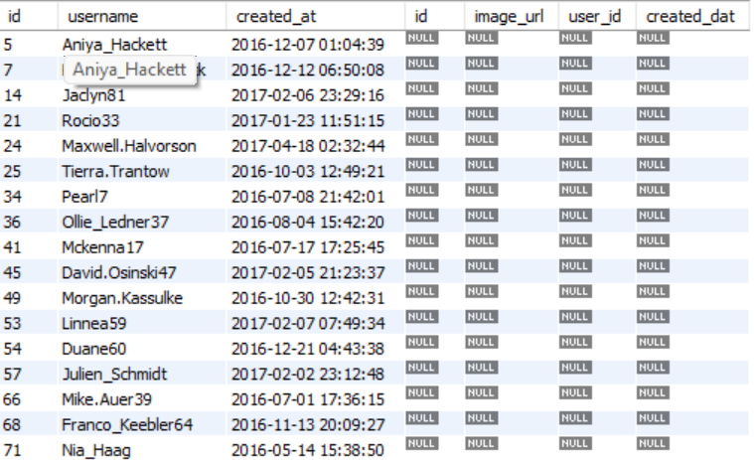

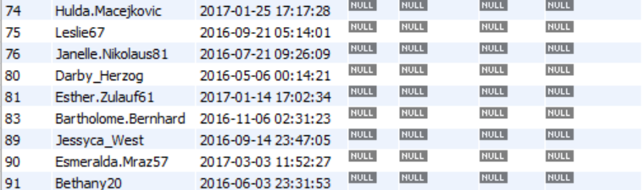

**CONCLUSION:** The above-mentioned are the Instagram users with zero posts**.**

3)Contest Winner Declaration: The team has organized a contest where the user with the most likes on a single photo wins.  
Your Task: Determine the winner of the contest and provide their details to the team.

**CODE**:

**select users.id, username, photo_id, count(likes.user_id) as total_likes from users**

**join photos**

**on users.id=photos.user_id**

**join likes**

**on likes.photo_id=photos.id**

**group by photos.id**

**order by total_likes desc**

**limit 1;**



**CONCLUSION:** Zack_kemmer93 whose user_id is 52 gained 48 likes on a photo with photo_id 145.

4)**Hashtag Research:** A partner brand wants to know the most popular hashtags to use in their posts to reach the most people.  
Your Task: Identify and suggest the top five most commonly used hashtags on the platform.

**CODE**:

**select tag_name, count(*)as count_of_tags from photo_tags**

**join tags**

**on tags.id=photo_tags.tag_id**

**group by tag_name**

**order by count_of_tags desc**

**limit 5;**

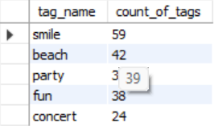

**CONCLUSION:** The above-mentioned are the top 5 most commonly used hashtags on the platform.

5)**Ad Campaign Launch:** The team wants to know the best day of the week to launch ads.  
Your Task: Determine the day of the week when most users register on Instagram. Provide insights on when to schedule an ad campaign.

**CODE:**

**select dayname(created_at) as day_name, count(username) as count**

**from users**

**group by day_name**

**order by count desc;**

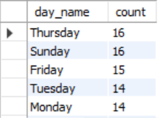

**CONCLUSION:** Thursday and Sunday are the days when most users register on Instagram.

Hence, these days is best to schedule ad campaigns**.**

**(B)Investors Metrics:**

**1)User Engagement:** Investors want to know if users are still active and posting on Instagram or if they are making fewer posts.  
Your Task: Calculate the average number of posts per user on Instagram. Also, provide the total number of photos on Instagram divided by the total number of users.

**CODE:**

**select**

**(select count(*) from photos)/ (select count(*) from users)**

**as average_posts_per_user;**



**CONCLUSION**: 2.57 is the average number of posts per user on the platform.

**2)Bots & Fake Accounts:** Investors want to know if the platform is crowded with fake and dummy accounts.  
Your Task: Identify users (potential bots) who have liked every single photo on the site, as this is not typically possible for a normal user.

**CODE:**

**select user_id, count(*) as likes_count from likes**

**group by user_id**

**having likes_count =(select count(*) from photos);**

**select username, count(*) as likes_count from users**

**join likes**

**on users.id= likes.user_id**

**group by user_id**

**having likes_count=(select count(*) from photos);**

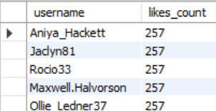

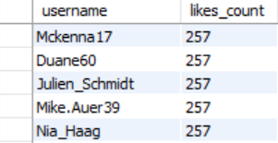

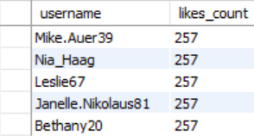

**CONCLUSION: Following is the list of usernames that have liked every post on the platform that are possibly bots.**